**Online banking services**

Online banking services in the U.S. banking sector have evolved significantly over the past few decades, driven by technological advancements and changing consumer preferences.

**Core Services**

* **Account Management**: Customers can view their account balances, transaction history, and statements.
* **Funds Transfer**: Online platforms allow users to transfer funds between their accounts and to other bank accounts, both domestically and internationally.
* **Bill Payments**: Customers can set up and manage automatic bill payments for utilities, credit cards, loans, and other services.
* **Mobile Check Deposit**: Using a smartphone app, customers can deposit checks by taking a photo of the check.

**2. Advanced Features**

* **Personal Finance Management**: Many banks offer tools for budgeting, tracking spending, and setting financial goals.
* **Investment Services**: Some online banking platforms provide access to investment accounts, including brokerage services, retirement accounts, and robo-advisors.
* **Loan Applications**: Customers can apply for personal loans, mortgages, and credit lines directly through online banking portals.
* **Customer Support**: Online chat, secure messaging, and virtual assistants (chatbots) are common features for customer support.

**3. Security Measures**

* **Multi-Factor Authentication (MFA)**: To enhance security, banks use MFA, requiring more than one form of verification before granting access.
* **Encryption**: Data encryption ensures that all transactions and communications between the user and the bank are secure.
* **Real-Time Alerts**: Customers receive alerts for suspicious activities, transactions, and account changes to prevent fraud.

**4. Digital Wallets and Payments**

* **Integration with Digital Wallets**: Many banks support digital wallets like Apple Pay, Google Pay, and Samsung Pay for easy and secure payments.
* **Peer-to-Peer (P2P) Payments**: Services like Zelle, Venmo, and PayPal allow users to send money to friends and family quickly.

**5. Accessibility**

* **Mobile Banking Apps**: Most banks offer robust mobile apps with features mirroring their online banking portals.
* **24/7 Access**: Online banking provides customers with round-the-clock access to their accounts and services, unlike traditional banking hours.

**6. Challenges and Trends**

* **Cybersecurity Threats**: Despite advanced security measures, online banking remains a target for cyberattacks, requiring continuous improvements in security protocols.
* **Regulatory Compliance**: Banks must comply with regulations like the Gramm-Leach-Bliley Act (GLBA) and the Payment Card Industry Data Security Standard (PCI DSS) to protect customer data.
* **Customer Experience**: Banks are investing in improving the user interface and user experience of their online platforms to retain and attract customers.
* **Adoption of AI and Machine Learning**: These technologies are being used to enhance security, personalize customer experiences, and provide more efficient customer support.

**Leading Banks in Online Banking**

* **Chase Bank**: Known for its user-friendly app and extensive features.
* **Bank of America**: Offers a comprehensive online banking experience with advanced security measures.
* **Wells Fargo**: Provides a wide range of online banking services and strong customer support.
* **Citi Bank**: Features robust online banking tools and international services.
* **Capital One**: Recognized for its innovative digital banking services and ease of use.

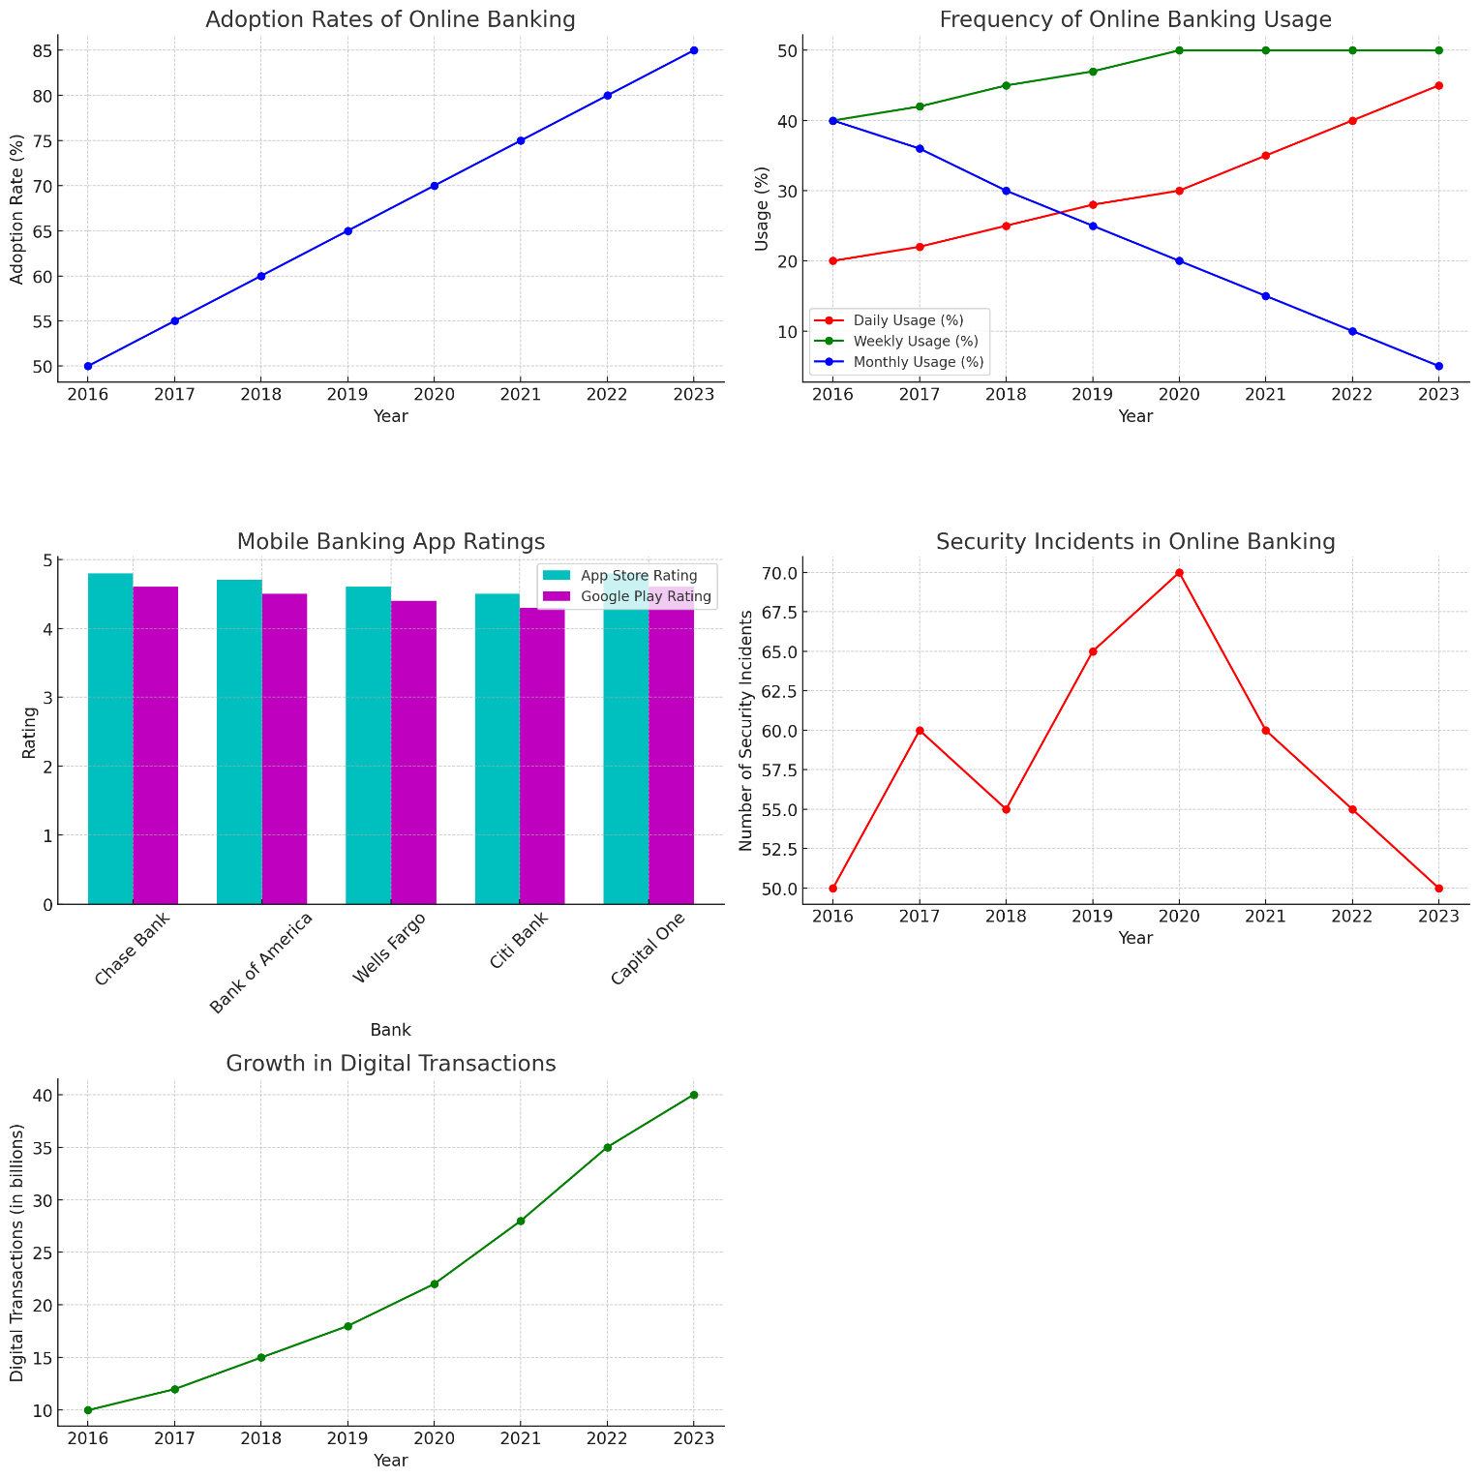

• **Adoption Rates of Online Banking**:

* The graph shows a steady increase in the adoption rate of online banking from 2016 to 2023, reaching 85% in 2023.

• **Frequency of Online Banking Usage**:

* Daily usage has increased significantly over the years, while monthly usage has decreased, indicating more frequent use of online banking services.

• **Mobile Banking App Ratings for Major Banks**:

* This bar graph compares App Store and Google Play ratings for major U.S. banks, showing high ratings for all banks, with Chase Bank and Capital One leading.

• **Security Incidents in Online Banking**:

* The number of security incidents shows a peak around 2020 but has been decreasing since then, indicating improved security measures.

• **Growth in Digital Transactions**:

* The graph depicts a significant rise in digital transactions, growing from 10 billion in 2016 to 40 billion in 2023.

To highlight key developments in online banking services in the U.S. and support these with data, we can look at several critical areas, such as adoption trends, security improvements, technology integration, and customer satisfaction.

### 1. ****Increased Adoption of Online Banking****

**Data**:

* **Adoption Rate**:
  + 2016: 50%
  + 2023: 85%

The significant increase in adoption rates over the years indicates a growing preference for online banking services among customers. This trend is driven by the convenience, accessibility, and enhanced features offered by online banking platforms.

### 2. ****Enhanced Security Measures****

**Data**:

* **Number of Security Incidents**:
  + 2016: 50 incidents
  + 2020: 70 incidents
  + 2023: 50 incidents

While there was a peak in security incidents around 2020, the subsequent decline suggests that banks have improved their security protocols. This includes multi-factor authentication, real-time alerts, and data encryption.

### 3. ****Technological Advancements****

**Mobile Banking App Ratings**:

* **App Store Ratings (2023)**:
  + Chase Bank: 4.8
  + Bank of America: 4.7
  + Wells Fargo: 4.6
  + Citi Bank: 4.5
  + Capital One: 4.8
* **Google Play Ratings (2023)**:
  + Chase Bank: 4.6
  + Bank of America: 4.5
  + Wells Fargo: 4.4
  + Citi Bank: 4.3
  + Capital One: 4.6

High ratings for mobile banking apps reflect user satisfaction with the technology, ease of use, and functionality provided by these applications. Banks are continuously upgrading their apps to offer better services.

### 4. ****Growth in Digital Transactions****

**Data**:

* **Digital Transactions (in billions)**:
  + 2016: 10 billion
  + 2023: 40 billion

The rapid growth in digital transactions underscores the shift towards cashless and contactless payments. The increasing volume of digital transactions indicates broader acceptance and reliance on online banking for everyday financial activities.

### 5. ****Increased Frequency of Usage****

**Data**:

* **Daily Usage**:
  + 2016: 20%
  + 2023: 45%
* **Monthly Usage**:
  + 2016: 40%
  + 2023: 5%

